Opening Moves Analysis in Chess
Identifying Winning Strategies through Opening Moves Analysis in Chess

Pranav Barathwaj
Luddy School of Informatics, Computing and Engineering
IUPUI
Indianapolis, United States of America
ppadman@iu.edu

Abstract— In this project, we identify the opening moves of chess that are most likely to result in a win for either white or black, based on player ratings. By analyzing a large dataset of chess games played by different skilled players in various timed games without increments for each move, this project will identify patterns and trends in the opening moves played. The objective is to develop a model that can predict the likelihood of a win based on the opening moves played, which will help find the most suitable opening moves for a given player based on their skill level.
Index Terms—Chess, Opening Moves, Pattern Recognition, Game Strategy, Player Ratings.

Introduction
Chess is a game that requires strategic thinking and careful planning from the very first move. The opening moves of a game can greatly impact its outcome, and understanding which moves are most likely to result in a win can provide players with a competitive advantage [4]. This project aims to identify the opening moves of chess that are most likely to lead to a win for either white or black, based on the player ratings. By analyzing games played by different skilled players in various timed games without increments for each move, this project will identify patterns and trends in the opening moves played. This analysis will help identify the most suitable opening moves for a given player based on their skill level, as well as provide insights into the strategies used by successful players. The project will utilize data analysis techniques to analyze a large dataset of chess games, including player ratings, opening moves played, and game outcomes. The results of this analysis will be used to develop a model that can predict the likelihood of a win based on the opening moves played. Overall, the project aims to provide valuable insights into the opening moves of chess and how they can impact the outcome of a game. By understanding which opening moves are most likely to lead to a win, players can improve their game and become more successful in competitive play [4].

Data in Use

Data Resources
The data resources used for this project is a chess data set containing data for more than 20,000+ games played on Lichess, an online platform for chess. The data resource was obtained from Kaggle, is available to the public, and was uploaded on the respective platform 2 years ago by a chess enthusiast ‘Mysar Ahmed Bhat’. The dataset was available as a ‘.csv’ file. Hence, there was no need to convert or transform the file. The usability of the data set was rated 10.0 considering the large amount of analysis data users can implement.

Data Description
The original dataset consisted of 17 attributes and 20058 records. After cleaning the data set according to the objective of the project, the data set consists of 7 attributes and 8916 records.

The attributes for the new data set include:
- Turns: Number of turns to finish a game. (Data Type: Numeric)
- Victory_Status: The way in which the game was won. Can either be a mate, resign or Out of Time. (Data Type: Categorical)
- Winner: Which color piece won the game. Either white or black. (Data Type: Numeric)
- Time: The duration of the match. (Data Type: Numeric)
- White_Rating: The rating of the player playing white. (Data Type: Numeric)
- Black_Rating: The rating of the player playing black. (Data Type: Numeric)
- Opening_Code: The corresponding code mentioned by FIDE for different openings of chess. This includes the different variations and opening responses. (Data Type: Categorical)

Attributes removed:
- Game ID: The game id of a chess match. (Data Type: Numeric)
- Rated: Says whether the game was rated or unrated. (Data Type: Categorical)
- Increment: The increment time for each move made in a game. (Data Type: Numeric)
- White_ID: The chess id name for the player playing white. (Data Type: Text)
- Black_ID: The chess id name for the player playing black. (Data Type: Text)
- Moves: Shows the moves of the entire game. (Data Type: Text)
- Opening_fullname: The full name for the opening. (Data Type: Categorical)
- Opening_shortname: The main name for the opening. (Data Type: Categorical)
- Opening_Response: The response to the opening by the person playing black. (Data Type: Categorical)
- Opening_Variation: The variation to the main opening. (Data Type: Categorical)

Data Cleaning Procedure
To analyze the opening codes and their effect on game results, some data-cleaning steps were taken. The attribute ‘increment’ was originally included to indicate the increment time for games, but since the analysis focused on normal timed games, games with no increment were filtered out using RStudio, and the ‘increment’ attribute was removed using Excel. The attribute ‘rated’ indicated whether the games were rated or not, but since non-rated games don't impact a player’s ratings, they were filtered out using RStudio, and the ‘rated’ attribute was removed using Excel. The attributes Opening_fullname, Opening_shortname, Opening_response, and Opening_variation were all removed because the attribute Opening_Code includes all the information contained in these attributes.
To analyze the relationship between opening codes and winning or losing a chess game, all games resulting in a draw were removed, resulting in the 'winner' attribute being either 'White' or 'Black'. To simplify the analysis, the 'winner' attribute was transformed into a numeric format by assigning 'White' as '0' and 'Black' as '1'.
Furthermore, the 'Opening_code' and 'Victory_status' attributes were converted to numeric data using the 'as.numeric' command in RStudio to streamline the analysis process. Therefore, opening codes and victory status will be presented as numerical values in the results.

Methodology

Classification Decision Tree
A classification decision tree is a type of data analysis that involves creating a visual representation of all possible choices and their possible consequences [1]. It is a hierarchical tree-like structure that is used to model decisions and their possible consequences. The tree starts with a root node and then branches out into a series of decision nodes, each of which represents a choice that needs to be made [1]. For the project, five decision trees were created to pick out the most preferred opening code for different classes of rated players. The trees created were based on:
- Label ‘opening_code’ in relation to 'white_rating' and 'black_rating' of the players.
- Label ‘winner’ in relation to 'white_rating' and 'black_rating' of the players.
- Label ‘winner’ in relation to ‘opening_code’.
- Label ‘victory_status’ in relation to 'white_rating' and 'black_rating'.
- Label ‘opening_code’ in relation to 'winner' and 'victory_status'.

Linear Regression
Linear regression is a statistical method used to model the relationship between a dependent variable and one or more independent variables [2]. For the project, linear regression summaries were analyzed for different linear regression models. The models created were:
- Label ‘opening_code’ in relation to 'white_rating' and 'black_rating' of the players.
- Label ‘winner’ in relation to 'white_rating' and 'black_rating' of the players.
- Label ‘winner’ in relation to ‘opening_code’.

Logistic Regression
It is a statistical method used to model the relationship between a binary dependent variable (i.e., a variable that can take only two values, such as win or lose) and one or more independent variables [3]. For the project, a logistic regression summary for label ‘opening_code’ in relation to ‘white_rating’ and ‘black_rating’ was created.

Results and Interpretations

Expected Results
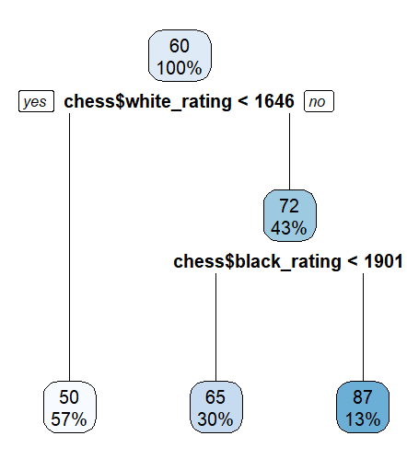
Three decision trees were successfully created and produced the expected results to give us valuable interpretations. The summaries for regression models also gave valuable information for our analysis.

Fig. 1. Decision tree with label 'opening_code' in relation with 'white_rating' and 'black_rating'

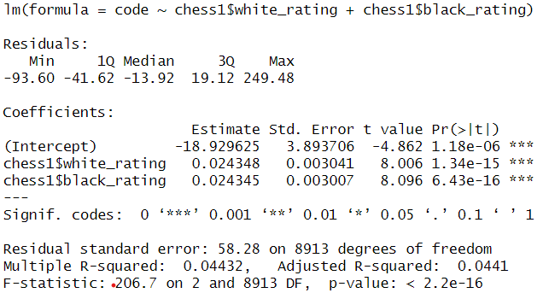
From Fig. 1., we can interpret a few things. For example, we can see that players playing white with a rating less than 1646 tend to play code 50. Since we have converted the 'opening_code' attribute into a numeric data type, it is necessary to decrypt it back into its original representation. In this particular case, the code '50' represents the "C46" opening, which can be further interpreted as the "Three Knights Game" [6]. This is just one of the possible interpretations obtained from the decision tree shown above. Further analysis and conclusions will be explained in the next section titled 'Conclusion'.
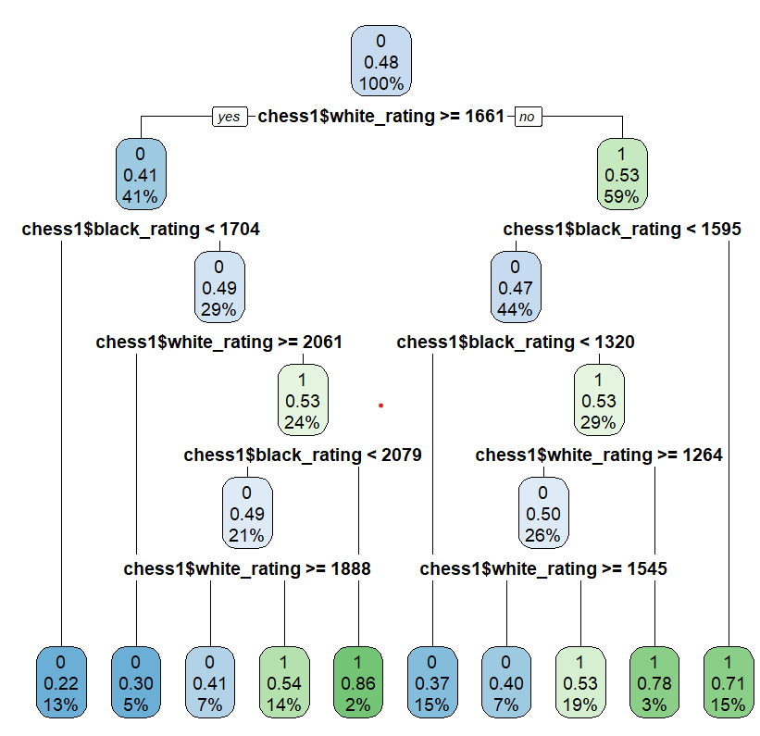

Fig. 2. Decision tree with label 'winner’' in relation with 'white_rating' and 'black_rating'

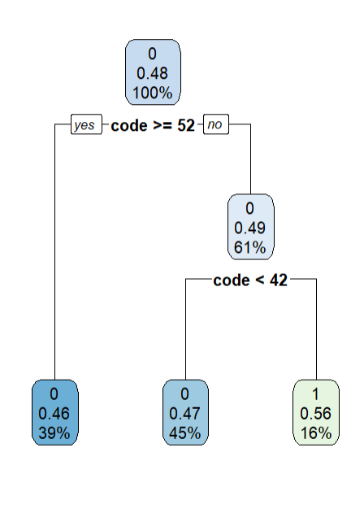
In Fig. 2. ‘0’ stands for white winning the game and ‘1’ stands for black winning the game. One of the interpretations from Fig. 2. can be that if a white-rated player lesser than 1661 faces a black-rated player greater than 1595, it will most likely result in black winning the game.

Fig. 3. Decision tree with label 'winner’' in relation with 'opening_code’

In Fig. 3. ‘0’ stands for white winning the game and ‘1’ stands for black winning the game. One of the interpretations from Fig. 3. can be that if games are played with an opening code greater than or equal to 52 or an opening code lesser than 42, it will result in white winning the game.

Fig. 4. Summary of a linear regression model with the label 'opening_code' in relation to 'white_rating' and 'black_rating'

From Fig. 4., we can interpret that the R-squared value of 0.04432 says that 4.432% of the total variation in 'opening_code' can be explained by the linear relationship between 'white_rating' and 'black_rating'. Fig. 5. also reveals that the coefficients for 'white_rating' and 'black_rating' are marked with '***', indicating that they are statistically significant in relation to 'opening_code' [5]. This emphasizes the importance of these attributes in determining the outcome of a game.

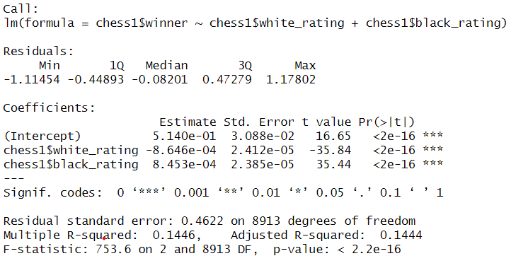

Fig. 5. Summary of a linear regression model with the label 'winner' in relation to 'white_rating' and 'black_rating'

From Fig. 5., we can interpret that the R-squared value of 0.1446 says that 14.46% of the total variation in 'winner' can be explained by the linear relationship between 'white_rating' and 'black_rating'. Fig. 5. also reveals that the coefficients for 'white_rating' and 'black_rating' are marked with '***', indicating that they are statistically significant in relation to 'winner' [5]. This emphasizes the importance of these attributes in determining the outcome of a game.
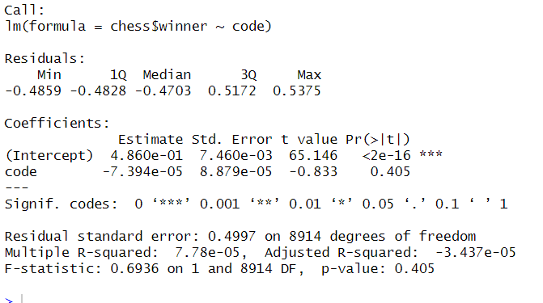

Fig. 6. Summary of a linear regression model with the label 'winner’' in relation to 'opening_code’

From Fig. 6., we can interpret that the R-squared value of 0.4997 says that 49.97% of the total variation in 'winner' can be explained by the linear relationship with ‘opening_code’. Fig. 6. also reveals that the coefficient estimates for 'opening_code' do not show statistical significance with respect to the 'winner' attribute, as indicated by the absence of the asterisk symbol (*) in the corresponding column [5].
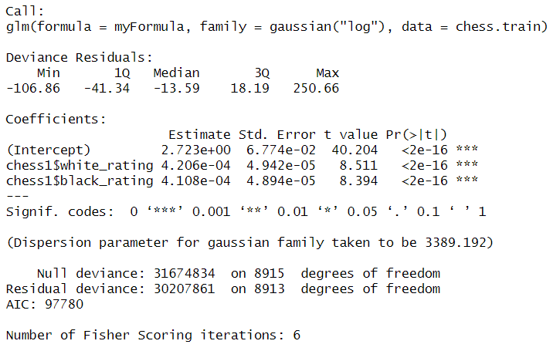
Fig. 7. Summary of a logistic regression model with the label 'opening_code' in relation to 'white_rating' and 'black_rating'.

We can see that Fig. 7. And Fig .4. are similar. They show that the coefficients of the independent variables are significant to ‘opening_code’.

Unexpected results
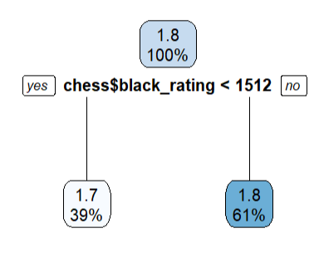
Out of all the expected results that were shown, there were a few unexpected results that didn’t contribute to the analysis.
Fig. 8. Decision tree with label 'victory_status’ in relation to 'white_rating’ and ‘black_rating’.
Fig. 8. does not provide the expected results as the 'victory_status' attribute consists of whole numbers, while the labels in the decision tree show decimal values. As a result, the labels in the decision tree may be misleading or difficult to interpret.
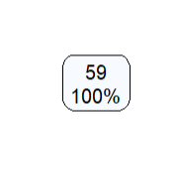
Fig. 9. Decision tree with label 'opening_code’ in relation to 'victory_status’ and ‘winner’.

Fig. 9. does not generate a proper decision tree with internal and leaf nodes, which may limit its usefulness for providing actionable insights.

Additional Results
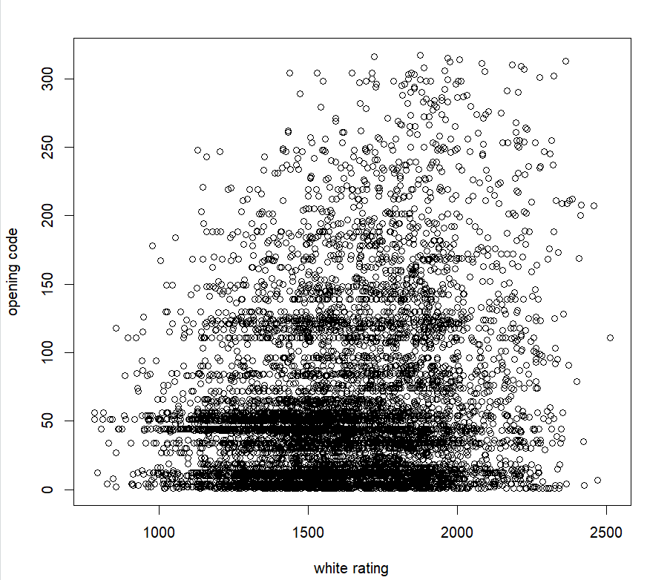

Fig. 10. Scatter plot showing the relation between ‘white_rating’ and ‘opening_code’.

From Fig. 10. we can see that a majority of players who play as white tend to use opening codes between 0 and 50. This finding provides valuable insights into the playing preferences and strategies of players in chess games.

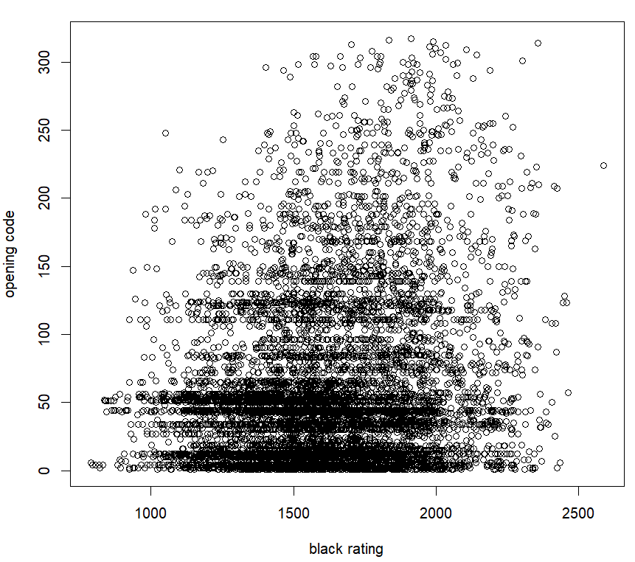
Fig. 11. Scatter plot showing the relation between ‘black_rating’ and ‘opening_code’.
From Fig. 11. we can see a similar trend to Fig. 10. where a majority of players who play as white tend to use opening codes between 0 and 50.

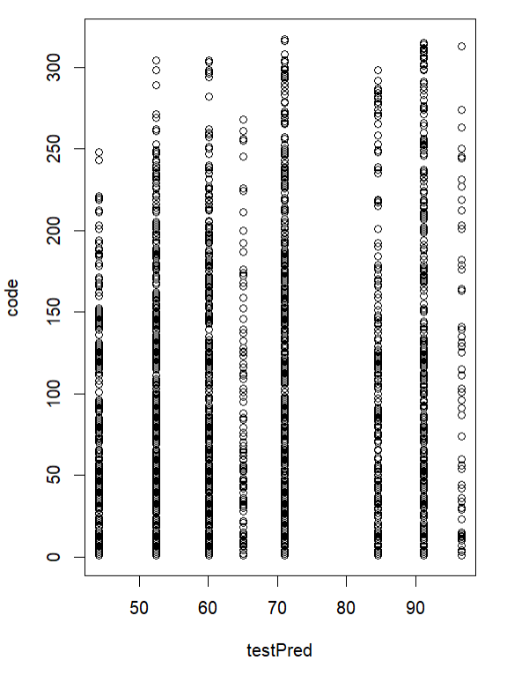
Fig. 12. Scatter plot showing the prediction of test data with "opening_code" of games

From Fig. 12. We can see that the model’s predictions aren’t aligning with the actual values. This may be due to the overfitting of data. But it can also be due to the large amount of categorical data in the dataset that is being used for the analysis.

Conclusion
The conclusion is solely based on the analysis obtained from the decision trees in Fig. 1., Fig. 2. And Fig. 3.

For low-rated players
- From Fig. 1., we see that players playing white with ratings less than 1646 tend to play opening code 50, corresponding to code 'C46'. This means they play the "Three-Knights game" [6].
- From Fig. 2., we see that when a white-rated player lesser than 1545 and greater than or equal to 1264 faces a black-rated player lesser than 1595 and greater than 1320, it will most likely result in black winning the game.
- From Fig. 3., we see that when games are played with opening code less than 52 and greater than 42, it will result in Black winning the game.
Therefore, from the above three conditions, we can conclude that if a player playing black is rated lesser than 1595 and greater than 1320 is facing a white-rated player lesser than 1545 and greater than or equal to 1264, the black-rated player should play an opening code between 42 and 52 but preferably code 50 which is the "Three-Knights game" to win the game.

For mid-rated players
The analysis for mid-rated players is very similar to low-rated players. This shows that both of them play similar styles.
- From Fig. 1., we see that players playing white with ratings less than 1646 tend to play opening code 50 which corresponds to code 'C46'. This means they play the "Three-Knights game" [6].
- From Fig. 2., we see that when a white-rated player lesser than 1661 faces a black-rated player greater than 1595, it will most likely result in black winning the game.
- From Fig. 3., we see that when games are played with opening code less than 52 and greater than 42, it will result in Black winning the game.
Therefore, from the above three conditions, we can conclude that if a player playing black is rated higher than 1595 and is facing a white-rated player lesser than 1661, the black-rated player should play an opening code between 42 and 52 but preferably code 50 which is the "Three-Knights game" to win the game.

For high-rated players
- From Fig. 1., we see that players playing black with ratings greater than 1901 tend to play opening code 87 which corresponds to code 'A02'. This means they play the "Bird's Opening" [6].
- From Fig. 2., we see that when a white-rated player greater than 1888 and lesser than 2061 faces a black-rated player greater than 1704 and lesser than 2079, it will most likely result in white winning the game.
- From Fig. 3., we see that when games are played with an opening code greater than or equal to 52 or an opening code lesser than 42, it will result in white winning the game.
Therefore, from the above three conditions, we can conclude that if a player playing white is rated higher than 1888 and lesser than 2061 is facing a black-rated player higher than 1704 and lesser than 2079, the white-rated player should play an opening code greater than 52 or lesser than 42, but preferably code 87 which is the "Bird's Opening" to win the game.

Conclusive Outcome
Based on the findings obtained in the project, we can conclude that the optimal opening moves for a given player are likely to depend on their skill level as well as the skill level of their opponent. This insight highlights the value of using data analysis to gain a better understanding of chess strategy and inform decision-making.
By leveraging advanced analytical techniques, researchers can gain valuable insights into the factors that influence game outcomes, such as the opening moves used by players [4]. These insights can be used to develop more effective strategies and improve overall gameplay.

Future Work
While this project has used some valuable attributes to analyze and gain insights, there is still potential for further analysis and improvement. From Fig. 4., Fig. 5., Fig. 6. and Fig. 7., we can infer that the R-squared value is low. This accounts for fairly low accuracy and this should be one of the areas of focus for future work. Similarly, there must be a significant focus on pre-processing techniques in ensuring that every result of the analysis is accurate and reliable. This project can also incorporate temporal analysis to investigate the impact of move sequences and their timings on the likelihood of winning, as players' strategies may change throughout the course of a game. Another opportunity is to use player names and analyze the best opening for a specific player.

References
- Pumalin, “Decision Trees for Classification – Complete Example,” Medium, Feb.05, 2023.
https://towardsdatascience.com/decision-trees-for-classification-complete-example-d0bc17fcf1c2
- Statistics Solutions, “What is Linear Regression?,” Statistics Solutions, 2013. https://www.statisticssolutions.com/free-resources/directory-of-statistical-analyses/what-is-linear-regression/
- ‌“What is Logistic Regression?,” Statistics Solutions. https://www.statisticssolutions.com/free-resources/directory-of-statistical-analyses/what-is-logistic-regression/
- ‌G. De Marzo and V. D. P. Servedio, “Quantifying the complexity and similarity of chess openings using online chess community data,” Scientific Reports, vol. 13, no. 1, Apr. 2023, doi: https://doi.org/10.1038/s41598-023-31658-w.
- ‌Zach, “How to Interpret Significance Codes in R,” Statology, Dec. 04, 2020. https://www.statology.org/significance-codes-in-r/#:~:text=When%20you%20perform%20regression%20analysis%20or%20ANOVA%20in
- E. Staff, “ECO Codes Table (Encyclopaedia of Chess Openings),” The Chess Journal, Sep. 17, 2021. https://www.chessjournal.com/eco/
‌

